**Priya Sharma** 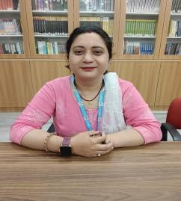

**Assistant Professor**

Nimbus Academy of Management **Area**  **Primary area :**

Human Resource Management **Secondary Area :**

Organizational Behaviour

# Contact

**Email :**

Priyasharma31659@gmail.co m **Phone :** 9027866411 Education

Pursing Doctoral Program (PHD) in Commerce , Manglayatan University Aligarh .

Master of Commerce, Swami Vivekananda Subharti University Meerut

BBA, Maharshi Dayananda University Rohtak

Bachelor of Education, Maharshi Dayananda University Rohtak

# Teaching

Human Resource Management

Organizational Behavior

# Research Area

Human Resource Management Organizational Behaviour

# Academic Experience

Faculty Member ,SRS Institute of Education and Technology Meerut,

December 2018 onwards

Faculty Member, Nimbus Academy of Management Dehradun ,November 2022 Onwards

**Professional Experience**

School of Management

# Seminars and Conferences

**Attended National Seminars on** Quality of Teaching in December (2014) by

V.B Convent college of Edcation

**Attended National Seminar** on How to write a Research Proposal in December (2023) by Nimbus Academy of Management as a organizing member

**Attended National Seminar** on Personality and Personal Grooming in March (2024) by Shree Sushila Devi Institute of Advanced Studies.